Title of the Paper (format:   
16pt, Times New Roman, bold, centered)

Name SURNAME (1), Name SURNAME (2), ... (format: 11pt, centered...)

1. Department, Center, University, Address. (Format: 0.5 cm left, right and French indents, justified, 10pt…)

2. Department, Center, University, Address.

Contact: Name SURNAME ([name.surname@email.com](mailto:name.surname@email.com)).

**ABSTRACT: (format: 12pt, bold, border at 12pt from text...)**

This MS-Word.docx file specifies the format of the papers for OPTOEL2025. It is recommended to use it as a template, since it contains the formats (font typeface and size, spacing, etc.) for each kind of paragraph (titles, abstract, main text, etc.).

The whole document’s font will be Times New Roman, with 11pt for the main text. The paper size must be A4 with 3 cm top and bottom margins, 3.5 cm interior and 2.5 cm exterior margins; headers and footers will be at 1.5 cm from the page border. Each abstract should summarize the most important findings of the paper in no more than 150 words.

The abstract must be written in English. The rest of the paper can be written in Spanish, although English is highly recommended.

For any further questions, please contact [congreso2025@optoel.es](mailto:congreso2025@optoel.es).

**Key words:** Format, specifications, manuscript, document, file, recommendations. (6-10 keywords)

# 1.- Introduction

The main text of the paper, like in this paragraph, will follow the format: 11pt, Times New Roman, justified, separated 6pt from the next paragraph, etc.

Files submitted in .pdf format must produce the same or very similar printing results, but ***all their footers should be blank***.

Especially important are: the paper size (A4), the margins (see Abstract above), the font (Times New Roman, or at least of the Times family), the two columns, and the footers of figures and tables with their numbering, as well as that of the equations. Headers and footers of MS-Word.docx files must also be like the ones in this document.

# 2.- Section

Section titles will be numbered 1.-, 2.-, 3.-, etc. (format: 12pt, bold, with 6pt separating space after, etc.). The format does not include the automatic numbering of sections (and, later, sub-sections, etc.) for simplicity and for there being a very limited number of them.

## 2.1.- Sub-section

Sub-section titles will be numbered 1.1.-, 1.2.-...; 2.1.-, 2.2.-..., etc., with (format: 10pt, bold).

### 2.1.1.- Sub-sub-section

If there exists any sub-sub-section, it may be titled using format: 10pt, italics, and numbering analogous to the previous one.

## 2.2.- Figures and tables

Figures and tables will be centered in their column. Their numbering will be as follows: Fig. 1, Fig. 2...; Table 1, Table 2... They will have a caption with a brief explanation (format: 10pt, justified/centered, italics, etc.).



*Fig. 1: The format for the figure caption is 10 pt, italics, justified, etc.*

*Table 1: The format for the table caption is 10 pt, italics, centered, etc.*

|  |  |  |
| --- | --- | --- |
| ***Column 1*** | ***Column 2*** | ***Column 3*** |
| *1.1* | *1.2* | *1.3* |
| *2.1* | *2.2* | *2.3* |
| *3.1* | *3.2* | *3.3* |

If a figure or table is too wide to fit inside a single column, it can temporarily interrupt the two columns in order to cover the whole page width (but respecting the global margins). This can be achieved, in MS-Word, by selecting the figure together with its paragraph, and then selecting in the menu: Format, Columns, One.

## 2.3.- Equations

For equations, it is recommended to use the main text format, but centering and numbering them on the right by means of tabulations:

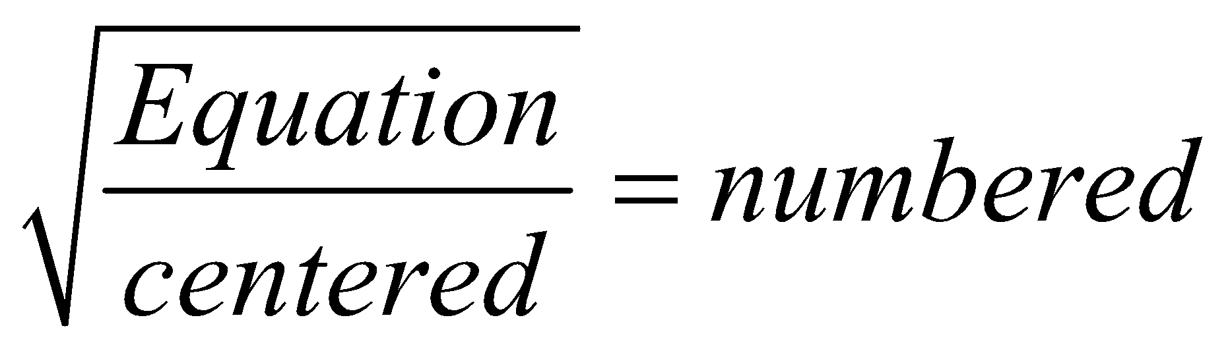 (1)

Equations will be numbered and referenced as (1), (2), etc. However, it will be not necessary to number equations which are referred to only in their vicinity.

## 2.4.- Format of bibliographical references

Bibliographical references and internet links will be numbered according to their order of appearance in the main text. They will be placed at the end of the document (format: 10pt, 0.7-cm-French indented) and numbered [1], [2], [3], etc. The format to reference journal papers, books, conference communications and internet links can be seen at the end of this document.

# 3.- FAQ

How can I divide a title into two lines at any desired point without altering the paragraph format (indents, etc.)?   
*Use a manual line feed (Shift-Enter in MS-Word), after a tabulation (if necessary).*

How many pages must the paper have?   
*No more than six pages.*

# 4.- Conclusion

The more uniform the aspect of the different papers is, the better the book of the proceedings will look. If the format of your article deviates substantially from the directives herein, you will have to re-submit your paper in full.

If you have any problems interpreting or implementing these instructions, please contact us at [congreso2025@optoel.es](mailto:optoel2023@us.es).

*Acknowledgements*: This work has been sponsored by…

*References*

[1] Name SURNAME (authors separated by commas), *“Paper Title”*, Journal, Volume, Number, pages, year.

[2] Name SURNAME (authors separated by commas), *“Book Title”* (Editing Co., year).

[3] Name SURNAME (authors separated by commas), *“Communication Title”*, in Proceedings of (name of Congress/ Conference), pages, year.

[4] Name of the web page or internet resource, <http://web.address.com>